First Christian Reformed Church | Rock Valley, IA
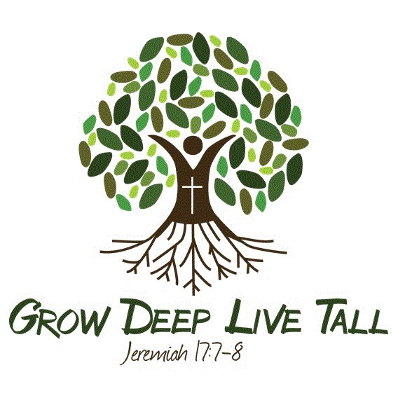
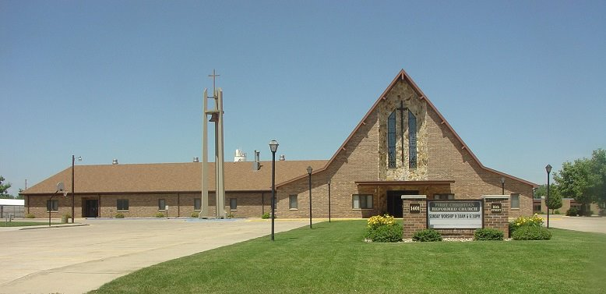
Care Group 8
RON LELOUX - Elder
Evan Altena – deacon
2024

RON LELOUX - CARE GROUP #8
Deacon Partner – Evan Altena
Mission Chair – Elmer Boon
Work Group Chair – Bonnie Wiersma
Work Group Co-Chair – Kim Van Tilburg

Members/Member Families
Donna Bakker
Myron & Amy Bleyenberg - Aftyn*, Bristyl*, Kolt*
Elmer & Lori Boon
Steve & April De Kam - Noah*, Gavin*
Brian & Renae Faber - Amera*
Jadyn Faber & Dylan Petitt+ - (both at Dordt – engaged)
Irene Groeneweg
Austin & Rachel+ Haak
Marva Haak
Cole Hoekstra*
Kyle Hoogendoorn
Mike & Ranae Kooistra
Evan & Rhonda LeLoux
Alex & Alexis Rust - River*, Jesse*
Grace Teunissen – Whispering Heights
Delanie Van Bemmel
Laura Van Kalsbeek
Merlin & Cindy Van Otterloo
Tim & Kim Van Tilburg
Carter Vanden Bos
Evan & Wanda Vanden Bosch
Harm & Bonnie Wiersma
Loy & Taryn Van’t Hul - Ethan, Addison*, Kennedy*
Macay Van’t Hul & Jesse Van Wyk+ - (both at NWC – engaged)
Blake & Ganae Zomer - Wyatt*, Gensen*

