First Christian REformed Church | Rock Valley, IA
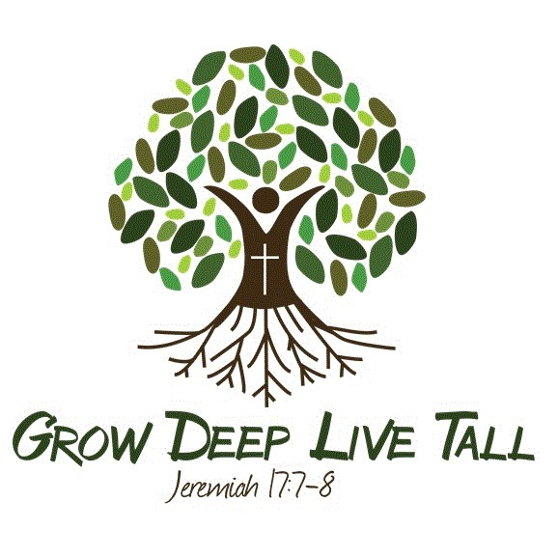
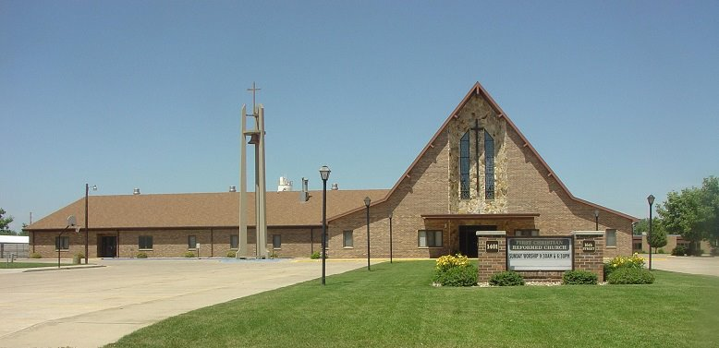
Care Group 7
Scott Koedam - elder
Ryan Zomer - deacon
2024

SCOTT KOEDAM - CARE GROUP #7
Deacon Partner - Ryan Zomer
Mission Chair – Jeff Elgersma
Work Group Chair & Co-Chair –
Rich & Lynette Rozeboom

Members/Member Families
Dan & Shannon Bloemendaal - Addisyn*, Eli*, Gracie*
Josh & Katie Byl - Emerson*, Saylor*
Justin & Lisa De Wit
Harold & June Driesen
Jeff & Stephanie Elgersma - Quincy*, Remi*, Sydnee*
Bob Gilman
Jeff Kats*
Roger & Hilaine Kempema
Matthew & Autumn Laman - Owen*, Miles*
Faye Medalen
Brian & Tricia Mulder - Rashana, Brock*
Tristan Mulder - NWC
Aysha Pollema - SDSU
Mike & Niki Pollema
Abigail Postma & Caleb Dokter+ - (both at Dordt – engaged)
Brad & Brenda Postma - Isaac*
Rich & Lynnette Rozeboom
Joan Van Maanen – Whispering Heights
Mike & Judy Van Otterloo
Warren Van Otterloo
Loy & Janice Van’t Hul
Mitchel & Shelby Van’t Hul – Crew*

Jerry Velgersdyk – Pleasant Acres-Hull

