first christian reformed church | rock valley, ia

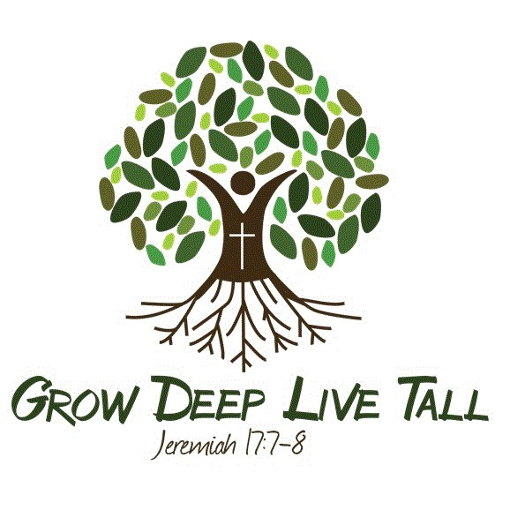

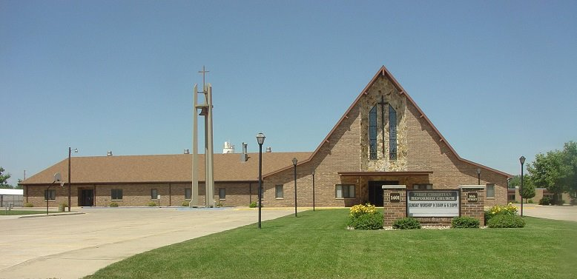

Care Group 6

DARWIN HOOGENDOORN - elder

myron bleyenberg - deacon

2024

**DARWIN HOOGENDOORN - CARE GROUP #6**

**Deacon Partner - Myron Bleyenberg**

**Mission Chair – Eric Breuer**

**Work Group Chair – Sharla Van Roekel**

**Work Group Co-Chair – Deb Hoekstra**

**Members/Member Families**

Karl & Alyssa Bos - Kayla*

Eric & Tracy Breuer - Teeghan*, Taryn*, Tessa*

Mitchell & Kelsi Byl - Harper*, Easton*, Palmer*

Zach & Jamie De Jager - Olivia*, Chetson*

John & Madeline+ De Wit

Jaden Den Boer+ & Katlein Van Der Weide+ - (engaged & joining in 2024)

Jim Driesen

Galen & Elsie Grevengoed

Leonard & Deb Hoekstra

Noah Jansma*

Clarence & MaryAnn Klarenbeek

Scott & Stephanie Koedam - Cooper*

Ron & Darletta LeLoux

Teresa Oostra – *Four Seasons*

Kyler Pollema

Matt & Krista Van Engen - Kayla*

Kimberly Van Otterloo

Harvey & Joanne Van Otterloo – *Whispering Heights*

Andy & Sharla Van Roekel - Aiden*, Jenessa*, Erica*, Darren*

Cody Van Tilburg*

Alvina Van’t Hul – *Whispering Heights*

Mary Van’t Hul

Trenton Van’t Hul

Gert Vis