first christian reformed church | rock valley, ia
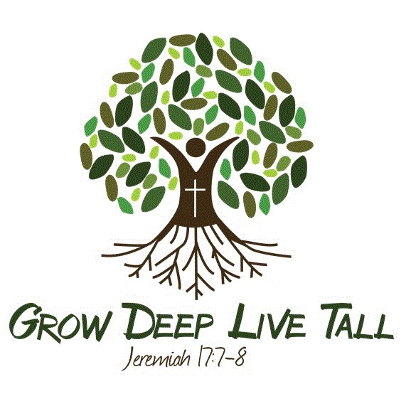
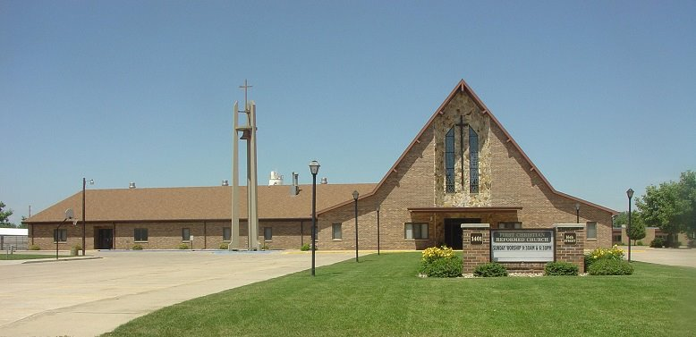
Care Group 5
Vern De Boer - elder
justin faber - deacon
2024
VERN DE BOER - CARE GROUP #5
Mission Chair – Larry Haak
Work Group Chair – Sue LeLoux
Work Group Co-Chair – Kendra Jansen
Deacon Partner - Justin Faber

Members/Member Families
Howard & Lynette Altena
Austin & Allison Bliek - Emeri*, Gentry*, Janie*
Randy & Pat Byl
Cody & Emileann Davelaar - Alayna*, Jake*, Kylie*
Clarence & Esther (Whispering Heights) De Roon
Zach Elbers & Lucy Borkowski+ - (engaged)
Larry & Yvonne Haak
Rev. Matthew & Holly Haan - Benjamin, Titus*, Ezra*, Andrew*
Kayla Hoogendoorn
Travis & Kendra Jansen – Kamden*
Dick & Carla Jansma
Hannah Jansma & Noah Krommendyk+ - (engaged)
Arnold Kempema
Chloe Koedam
Alvin & Sue LeLoux
Gene & Carla LeLoux
Jacob & Amanda Maassen
Jaslyn Van Otterloo
Eric & Erica Van Surksum - Savannah*, Jonah*
Alyssa Van’t Hul
Carol Van’t Hul
Mark & Deb Van’t Hul
Harriet Vande Kamp – Crown Pointe

