first christian reformed church | rock valley, ia
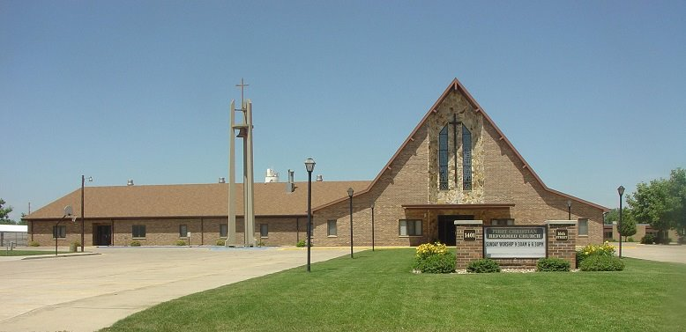
Care Group 2
RANDY VANDE KAMP - elder
MITCHELL BYL - deacon
2024
RANDY VANDE KAMP - CARE GROUP #2
Deacon Partner – Mitchell Byl
Mission Chair – Randy Vande Kamp
Work Group Chair – Tammy Baartman
Work Group Co-Chair – Lisa Pollema

Members/Member Families
Evan & Kim Altena - Taylor, Kaysha, Abby*
Mike & Tammy Baartman
Tyler & Alli Den Boer - Maclaine*, John*
Nathan Dorhout – River View Ridge
Harlan & Priscilla Driesen
Dawson+ & Allison (Postma) Feenstra
Brad & Nanci Grevengoed - Lydia*, Carson*, Connor*
Darwin & Tracy Hoogendoorn
Jonathon & TaMae Kats - Henry*, Griffin*
Pat Kats
Brett & Malorie Kirkley - Ada*, Faith*, Kya*
Ruth Koedam
Jarod LeLoux
Jennie Maassen – Whispering Heights
Ryan & Madison Olivera
Darin & Lisa Pollema - Hudsyn*, Deacon*, Jettson*
Caleb Van Beek
Dustin & Jodi Van Beek - Kilee*
Hunter Van Beek – UNI
Albert & Grace Van Grootheest
Matthew & Julianna+ Van Otterloo
Mike Van Zanten
James & Rachelle Vanden Bos
Levi Vanden Bos - SDSU
Jo Vander Schaaf

