first christian reformed church | rock valley, ia



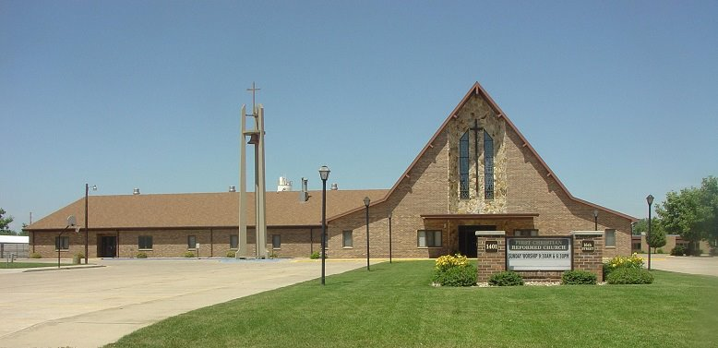

Care Group 1

Evan vanden bosch - elder

travis jansen - deacon

2024

**Mission Chair – Vern Van Beek**

**Work Group Chair – Joyce Van Engen**

**Work Group Co-Chair – Kacie Van Bemmel**

**EVAN VANDEN BOSCH - CARE GROUP #1**

**Deacon Partner - Travis Jansen**

**Members/Member Families**

Rodrigo+ & Alyson (Hoogendoorn) Banda – Isaiah***

Elaine Bolkema

Jasmine Bos

Doug De Roon

Justin & Josie Faber – Quinnley*

Violet Haak – *Whispering Heights*

Mike & Tammy Haverhals

Chance Hoekstra*

Sara Johnson - Charlie*, Caleb*, Brylie*

Galen & Paula Kats

Alex & Michelle Kooima - Dawson*, Tate*

Bob Kooima

Darin & Megan Kooima - Kenzie*, Easton*

Vern & Ellen Van Beek

Jeff & Kacie Van Bemmel - Ryder, Harper*

Mary Ann Van Bemmel – *Whispering Heights*

Ver & Sandy Van Bemmel

Lyle & Joyce Van Engen

Cowan Van Kley - **Dordt**

Nate & Laurie Van Kley - Breya, Brennan*, Trevin*, Gracia*

Justin Van Otterloo

Starla Van Otterloo – Samantha*

Mike & Gert Van Regenmorter

Hannah Van Tilburg

Chad & Sandra Van’t Hul

Brody Van’t Hul – **Iowa Lakes**

Parker Van’t Hul - **USD**

Wyatt Van’t Hul - **Se.T**

Glenn & Leah Walls – Archie*